TAXAND ASIA SENIOR SCHOOL

Groupement d’intérêt économique - RCS: C 68

1B, Heienhaff - L – 1736 Senningerberg (Luxembourg)   
Banque et Caisse d’Epargne de l’Etat, Luxembourg  
IBAN LU49 0019 2855 1871 6000, BIC: BCEELULL

VAT identification: LU 220 135 38

KUALA LUMPUR, 27-29 AUGUST 2018

**SOFT SKILLS PROJECT**

To be presented on : Monday, 27 August 2018

To be submitted on : Friday, 24 August 2018 End of business by email

This presentation is a group project to be prepared before arriving for the Senior School.

Please prepare a presentation to be shared with your fellow Taxanders in the School on an interesting topic about how you handle the following issues in your respective home country based on your/ your Firm's experience. You can also interview your colleagues or research on how your Firm handles one of the following situations:

1. Managing team members
2. Gaining trust from clients
3. Dealing with challenging clients

The purpose of presentation is to share with your fellow Taxanders the art of cooperating with other cultures like yours. It will be about how you handle those situations in your home country and what is the practice in your home base.

For your presentation, use the Taxand Global power point slide format. You can find it in the Taxand website once you log in to 'My Taxand'.

Prepare a 10 - 15 minutes presentation.

Remember to use your presentation skills and time management. Make the most of your allotted time effectively.

Below is your assignment according to your respective Taxand Country.

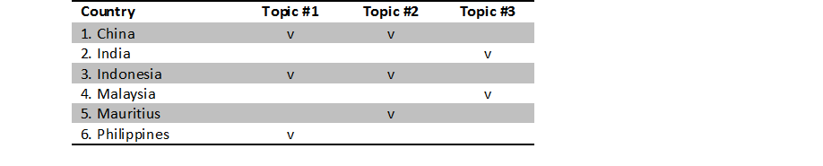

Please email your presentation at the latest on Friday, 24 August 2018 to henrietta.k@pbtaxand.com and cc to [indria.h@pbtaxand.com](mailto:indria.h@pbtaxand.com)

Should you have any question regarding the project, feel free to contact me.

Thank you!

Henrietta Kristanto

Taxand Indonesia